AWS Network Load Balancer (NLB) Lab Exercise
Objective
In this lab, you will:
- Launch 2 EC2 instances
- Install and configure Apache Web Server (httpd)
- Create a Network Load Balancer (NLB)
- Create a Target Group
- Register both EC2 instances
- Validate load balancing using a browser and curl
- Stop the web server on one instance and verify the NLB health check detects the failure

Architecture
Internet
|
Network Load Balancer
|
-------------------------------
| |
Target Group TCP:80
| |
------------------ ------------------
| | | |
EC2-Web1 EC2-Web2
Apache Apache
Port 80 Port 80

Prerequisites
- AWS Account
- Default VPC
- Key Pair
- Internet Gateway
- Public Subnets

Lab Tasks
Task 1: Create Security Group
Create a security group named:
WebServer-SG
Inbound Rules
Type | Port | Source
SSH | 22 | My IP
HTTP | 80 | 0.0.0.0/0
Outbound
Allow All
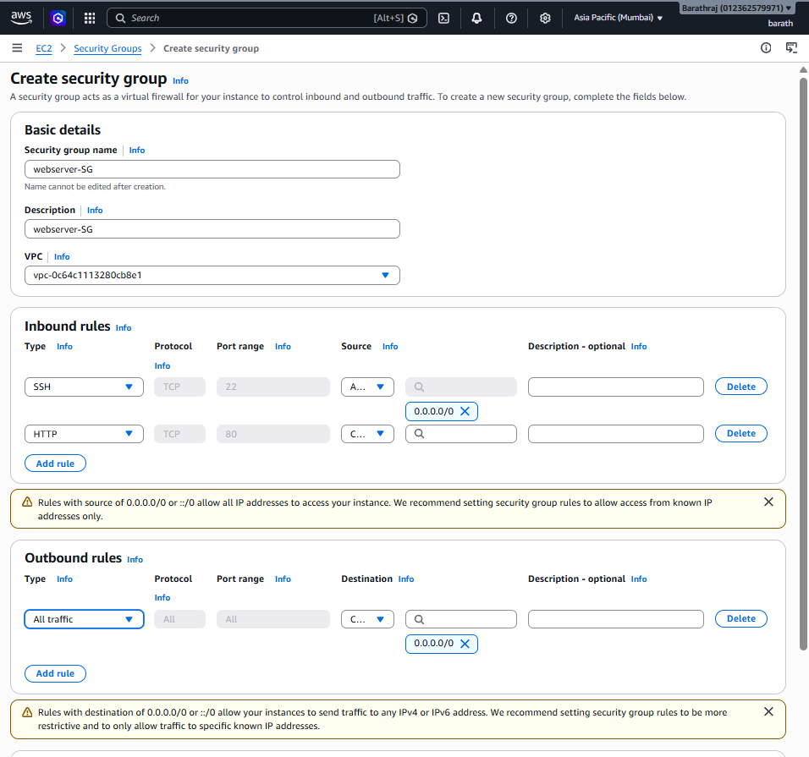
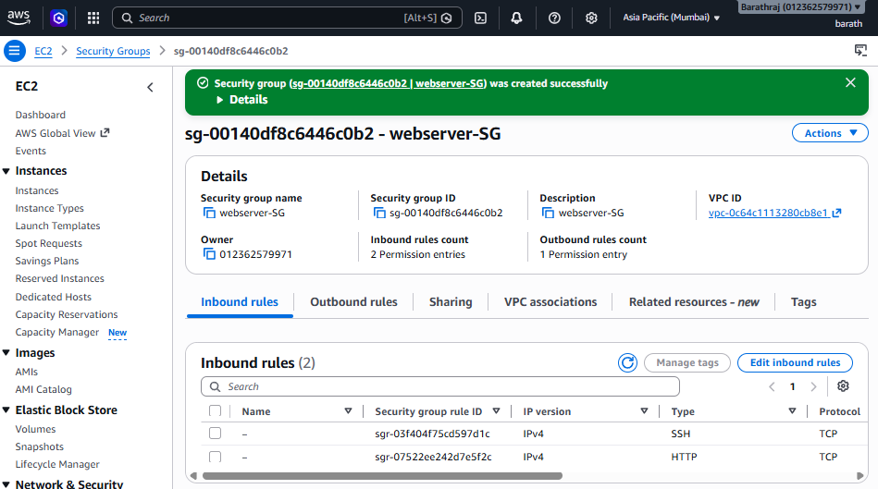

Task 2: Launch EC2 Instance-1
Name
WebServer-1
Configuration
- Amazon Linux 2023
- t2.micro
- Public Subnet
- Auto Assign Public IP
- Security Group: WebServer-SG
User Data
#!/bin/bash

yum update -y
yum install -y httpd

systemctl enable httpd
systemctl start httpd

cat <<EOF > /var/www/html/index.html
<html>
<body bgcolor="lightgreen">
<center>
<h1>Network Load Balancer Demo</h1>
<h2>Welcome to Web Server 1</h2>
</center>
</body>
</html>
EOF
Launch the instance.
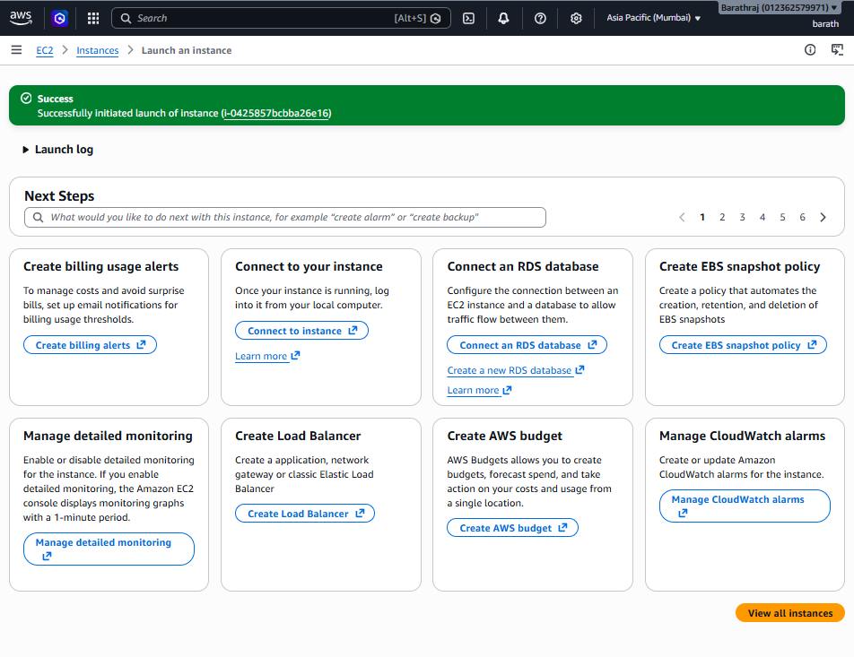


Task 3: Launch EC2 Instance-2
Name
WebServer-2
Use the following User Data.
#!/bin/bash

yum update -y
yum install -y httpd

systemctl enable httpd
systemctl start httpd

cat <<EOF > /var/www/html/index.html
<html>
<body bgcolor="lightblue">
<center>
<h1>Network Load Balancer Demo</h1>
<h2>Welcome to Web Server 2</h2>
</center>
</body>
</html>
EOF
Launch the instance.
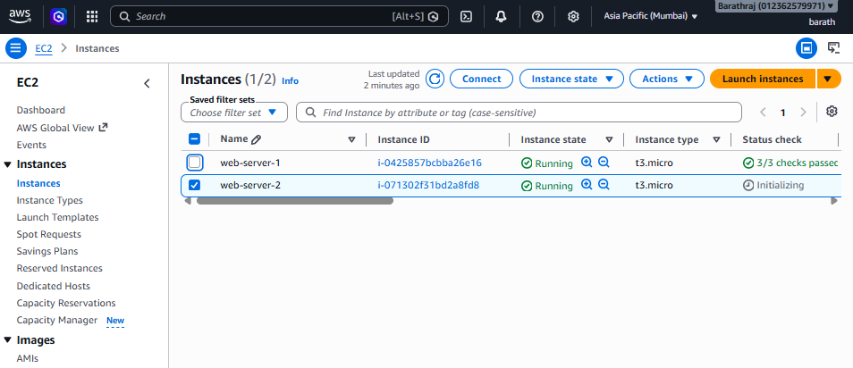


Task 4: Verify Web Servers
Open in browser
http://<EC2-1-Public-IP>
Expected
Welcome to Web Server 1
Open
http://<EC2-2-Public-IP>
Expected
Welcome to Web Server 2


Task 5: Create Target Group
Navigate to:
EC2
→ Target Groups
→ Create Target Group
Configuration
Setting | Value
Target Type | Instances
Name | NLB-TG
Protocol | TCP
Port | 80
VPC | Default VPC
Health Check
Option | Value
Protocol | HTTP
Path | /
Healthy Threshold | 3
Unhealthy Threshold | 2
Register
- WebServer-1
- WebServer-2
Create Target Group.
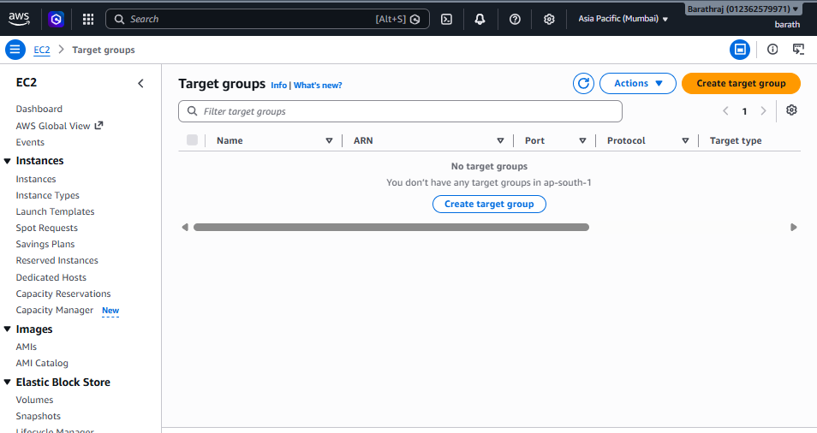
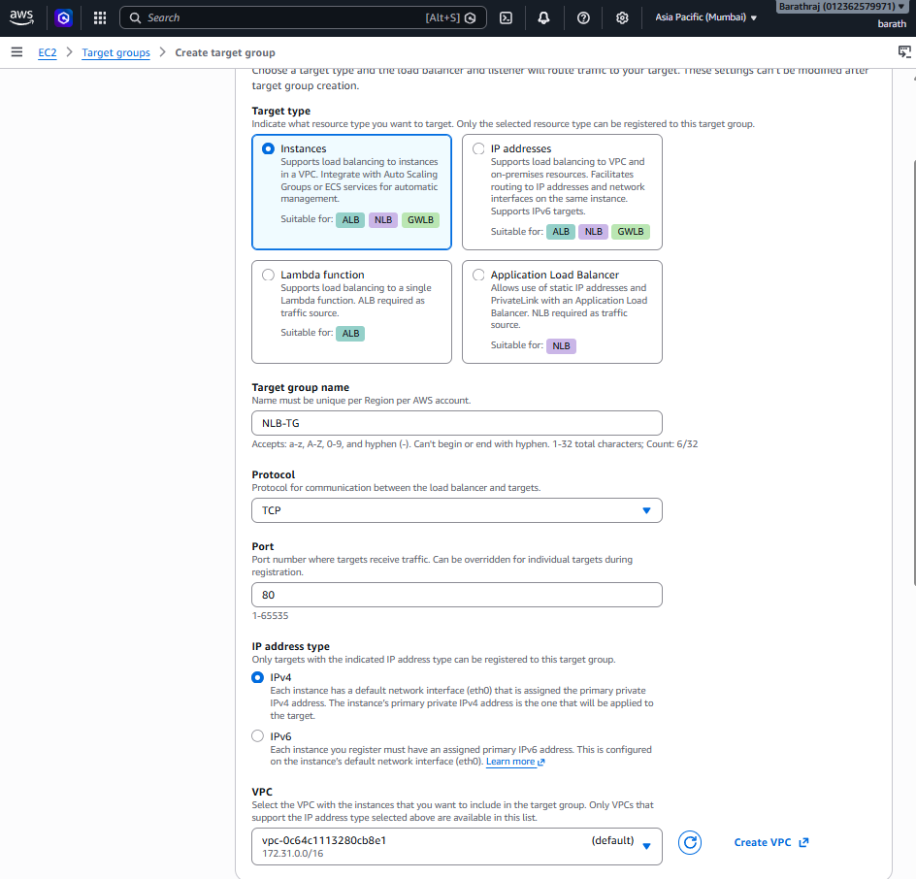
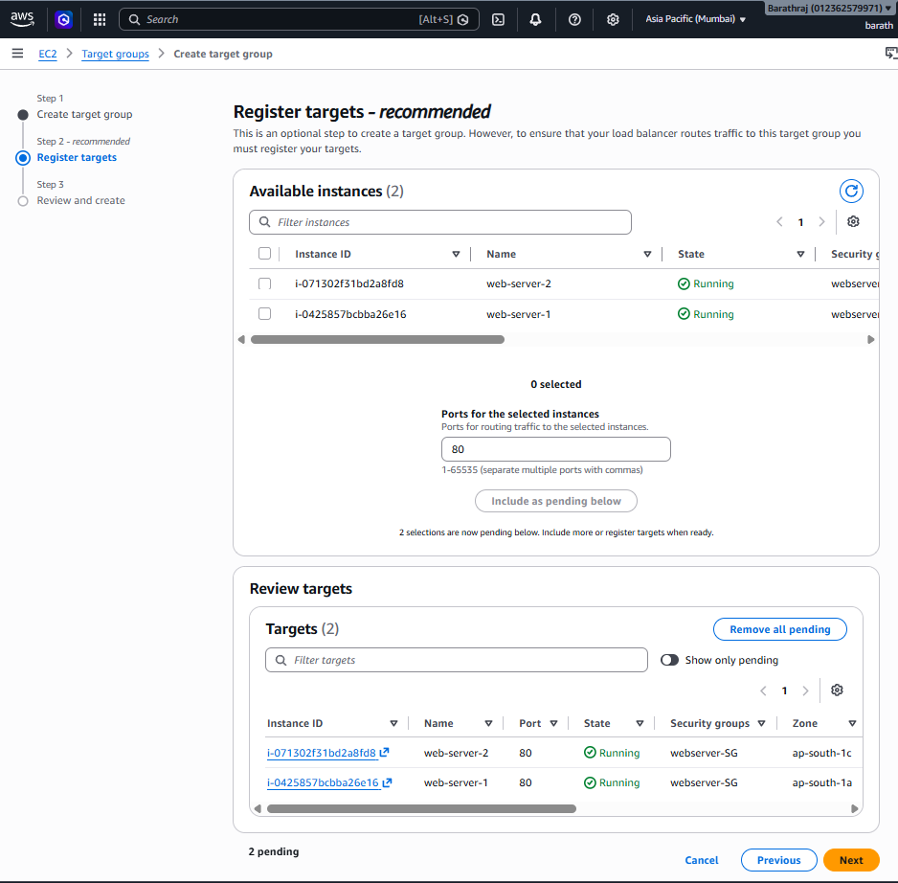
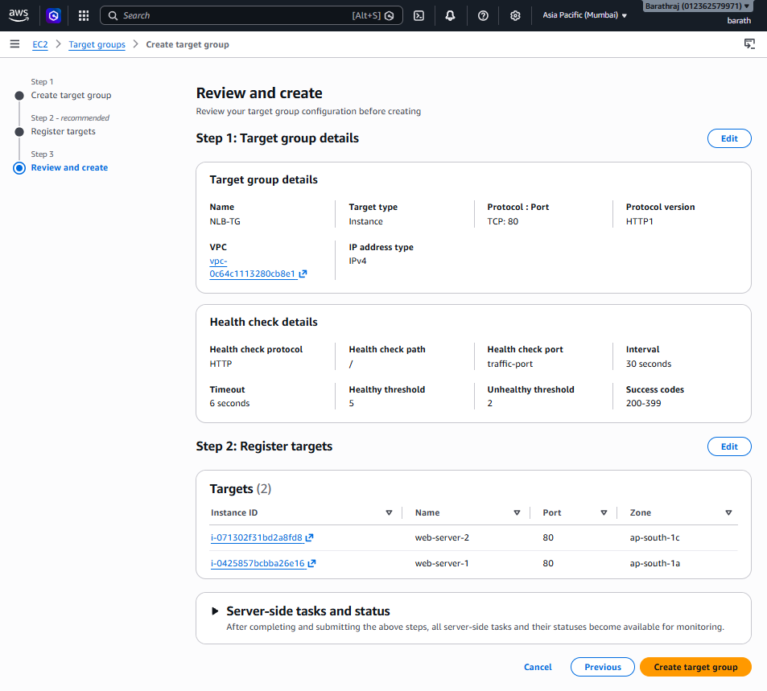
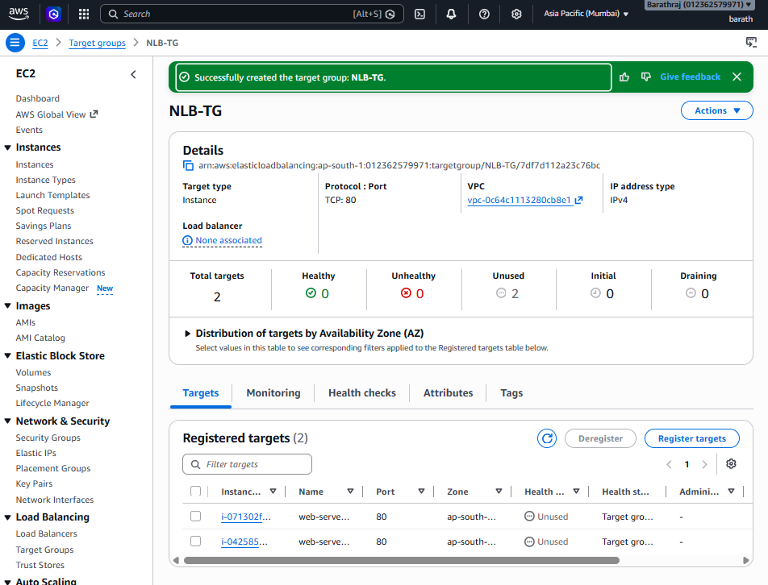

Task 6: Create Network Load Balancer
Navigate
EC2
→ Load Balancers
→ Create Load Balancer
→ Network Load Balancer
Configuration
Setting | Value
Name | NLB-Web
Scheme | Internet-facing
IP Type | IPv4
Listener | TCP :80
Select
- Two Availability Zones
- Public Subnets
Forward requests to
NLB-TG
Create Load Balancer.
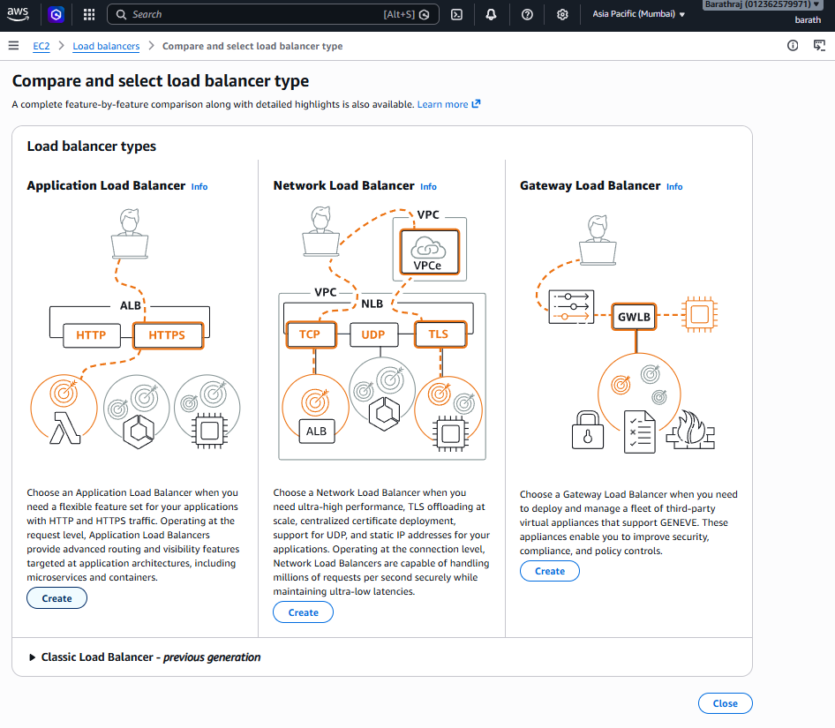
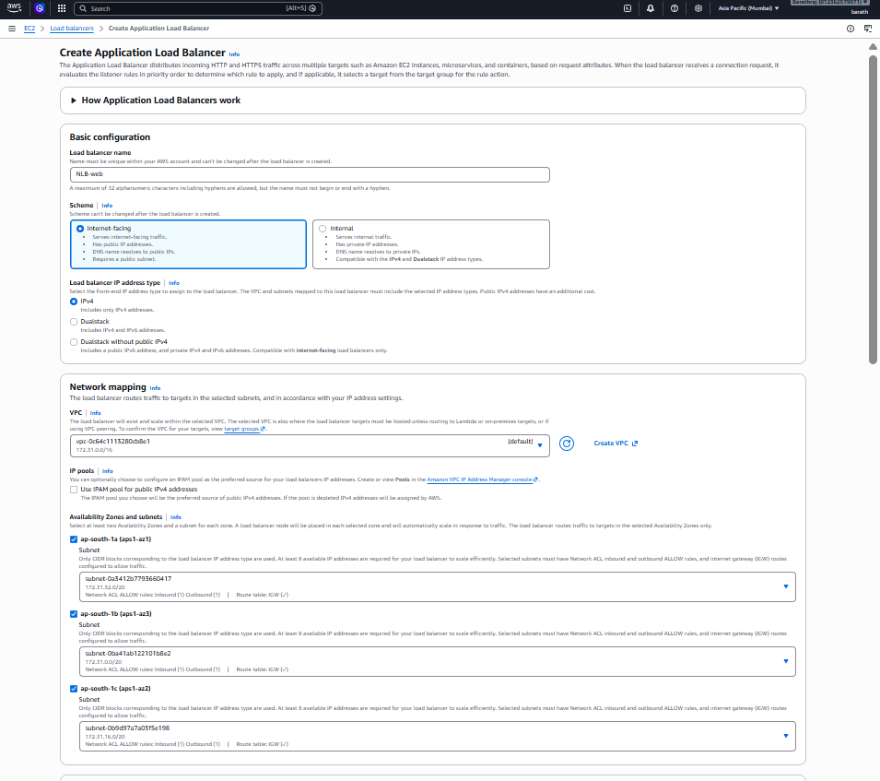
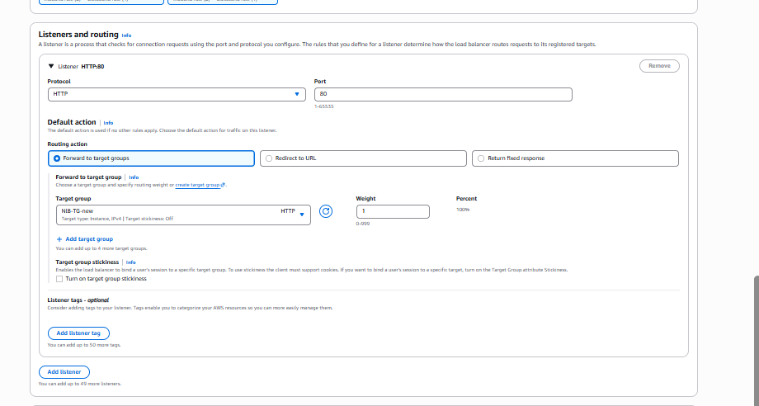
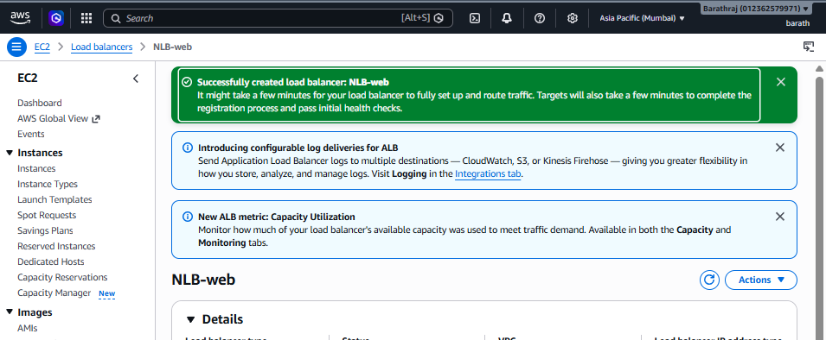
––

Task 7: Verify Target Health
Open
Target Groups
→ NLB-TG
→ Targets
Expected
WebServer-1 Healthy

WebServer-2 Healthy
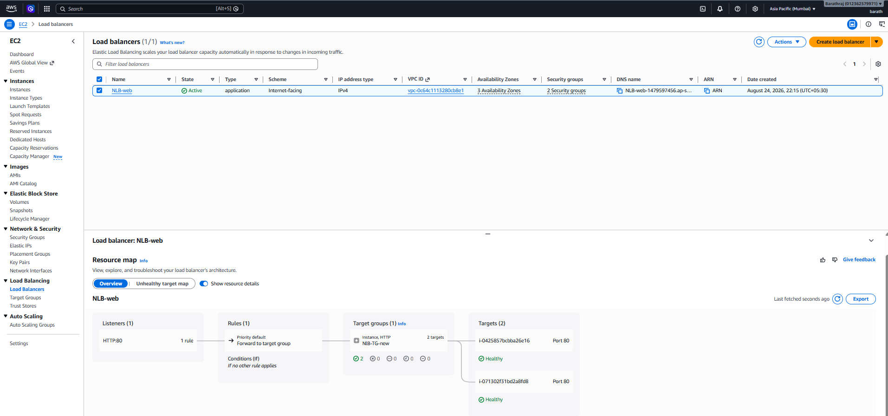

Task 8: Validate Using Browser
Copy the DNS name of the NLB.
Example
http://nlb-web-123456789.ap-south-1.elb.amazonaws.com
Refresh the page several times.
Expected:
- Requests are distributed to healthy targets. Because an NLB operates at Layer 4 (TCP), the backend selection depends on the TCP connection. If your browser reuses the same TCP connection (HTTP keep-alive), you may continue to see the same server.
- 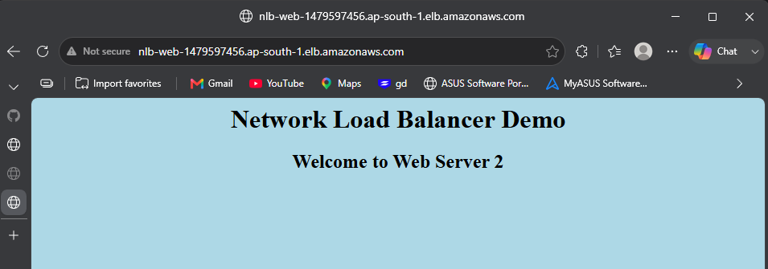
- 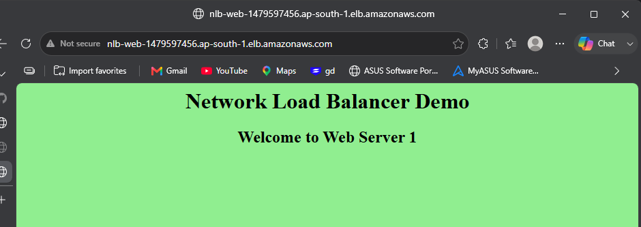

Task 9: Validate Using curl
Run:
curl http://<NLB-DNS>
Run multiple requests using new TCP connections:
for i in {1..10}
do
curl http://<NLB-DNS>
done
Or force HTTP/1.0 to reduce connection reuse:
for i in {1..10}
do
curl --http1.0 http://<NLB-DNS>
done
Expected: Responses may come from either Web Server 1 or Web Server 2 while both targets are healthy.

Task 10: Verify Health Checks
SSH to WebServer-1
Stop Apache
sudo systemctl stop httpd
Verify
systemctl status httpd
Expected
inactive (dead)
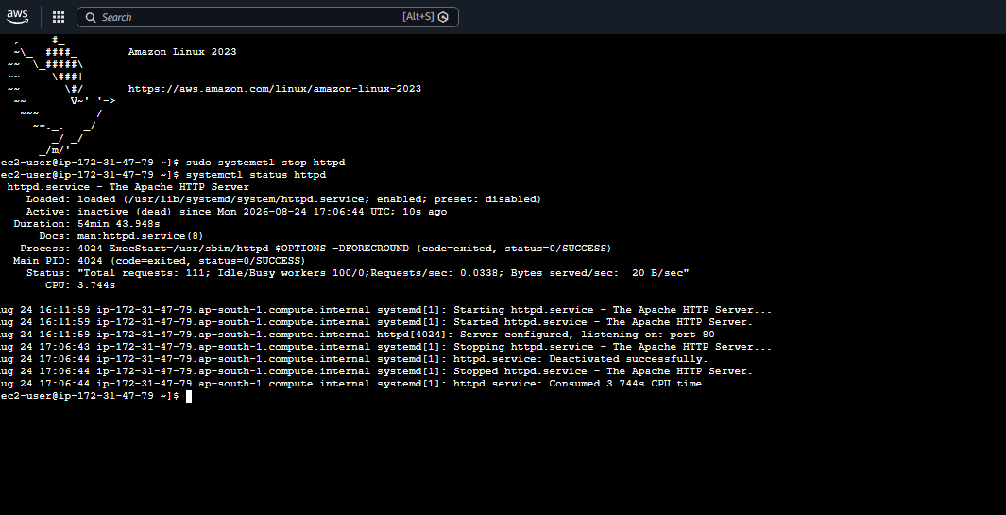

Task 11: Check Target Health
Navigate
Target Groups

↓

NLB-TG

↓

Targets
Wait 1–2 minutes.
Expected
WebServer-1

Unhealthy
Reason
Health checks failed
WebServer-2
Healthy
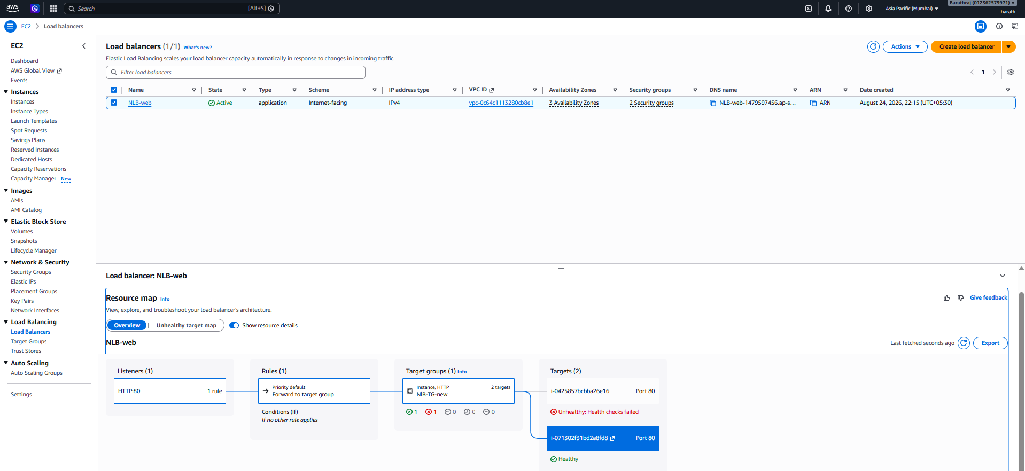

Task 12: Validate After Failure
Run
curl http://<NLB-DNS>
Repeat
for i in {1..10}
do
curl --http1.0 http://<NLB-DNS>
done
Expected
Welcome to Web Server 2
Only Web Server 2 should respond because Web Server 1 has failed the health checks.

Task 13: Recover the Failed Server
Start Apache again
sudo systemctl start httpd
Check status
systemctl status httpd
Verify the target health after a short wait:
Target Groups
→ NLB-TG
→ Targets
Expected
WebServer-1 Healthy
WebServer-2 Healthy
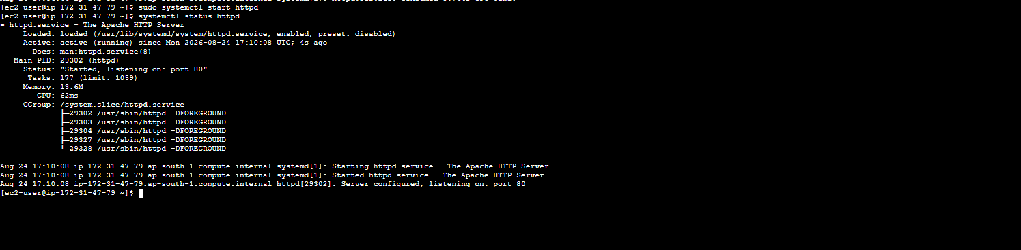
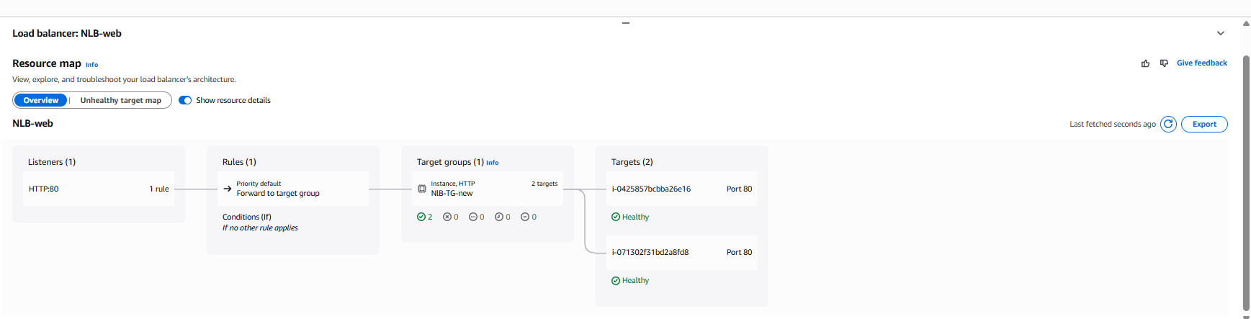

Task 14: Validate Again
Run
for i in {1..10}
do
curl --http1.0 http://<NLB-DNS>
done
Expected
Welcome to Web Server 1

Welcome to Web Server 2

Welcome to Web Server 1

Welcome to Web Server 2
Both servers should again receive traffic once the previously failed instance passes the health checks.
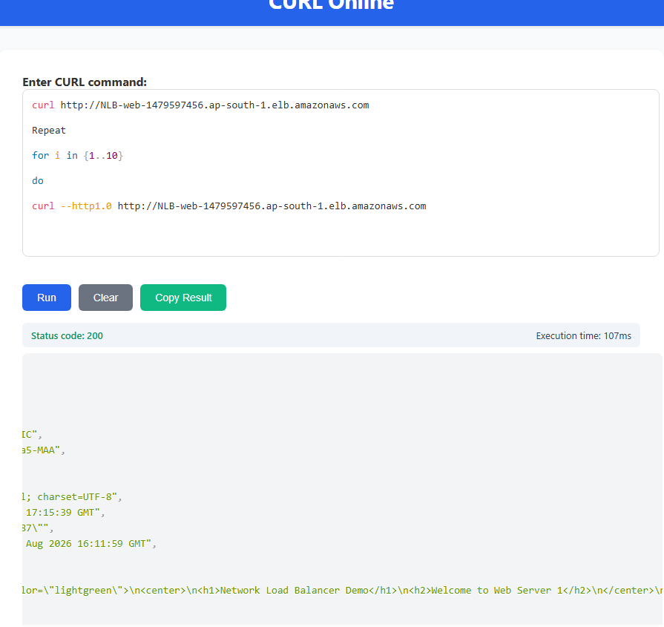

Expected Outcome
After completing this lab, you should be able to:
- ✅ Launch two EC2 web servers
- ✅ Configure the required security group
- ✅ Create a Target Group with HTTP health checks
- ✅ Create an Internet-facing Network Load Balancer
- ✅ Register EC2 instances as targets
- ✅ Validate access using a browser and curl
- ✅ Observe target health changes when httpd is stopped
- ✅ Confirm that the NLB sends traffic only to healthy targets
- ✅ Restore the failed server and verify it begins receiving traffic again

